**IBM CLOUD SERVICES ACCOUNT**

|  |  |
| --- | --- |
| DATE | OCT 27 2022 |
| TEAM ID | PNT2022TMID29355 |
| PROJECT NAME | SIGN WITH SMART CONNECTIVITY FOR BETTER ROAD SAFETY |

**TEAM LEADER: VIHA ASWINESRIEE SMR**

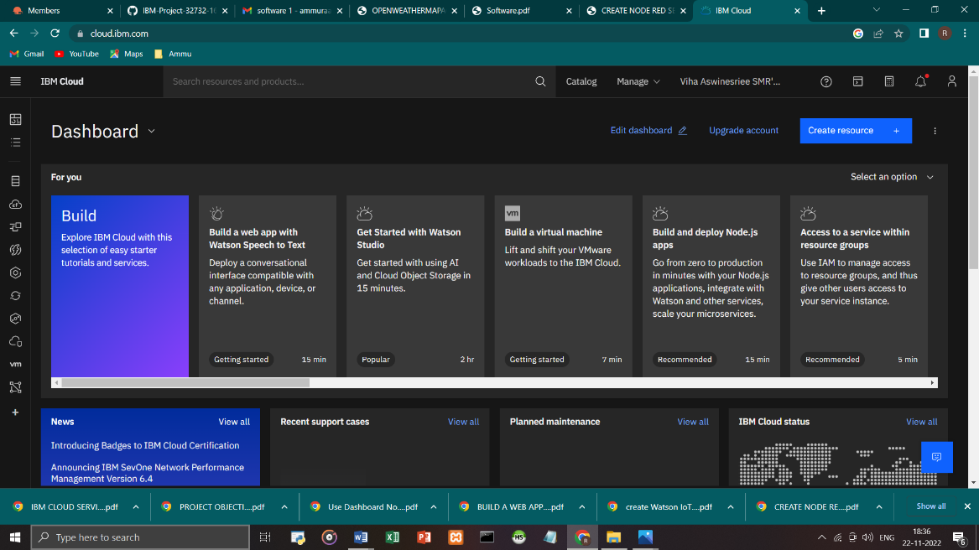

**TEAM MEMBER 1: RAAGAVI SELVAKUMAR**

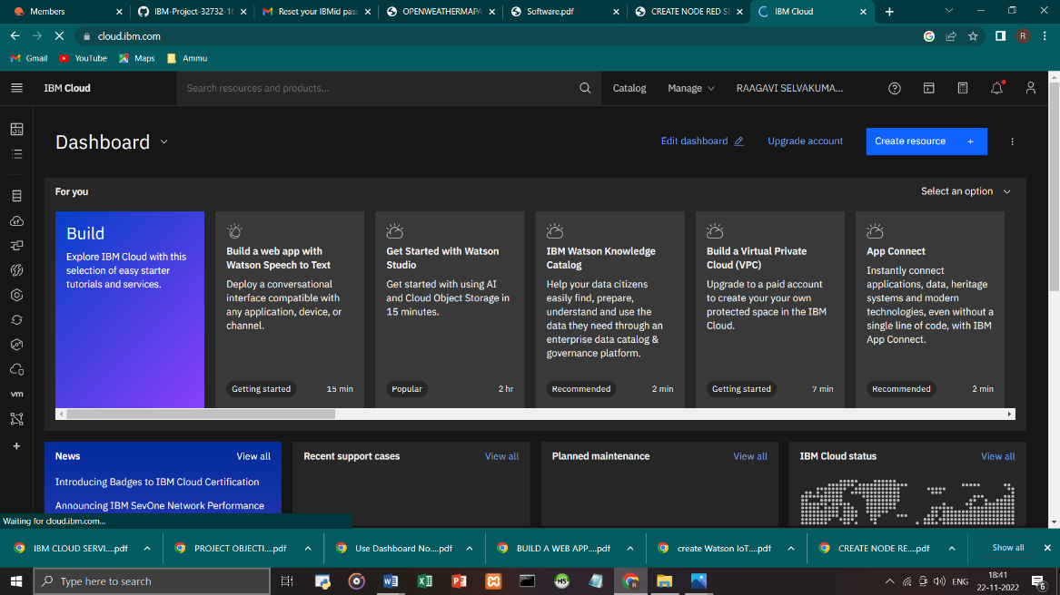

**TEAM MEMBER 2: PAVITHRA.V**

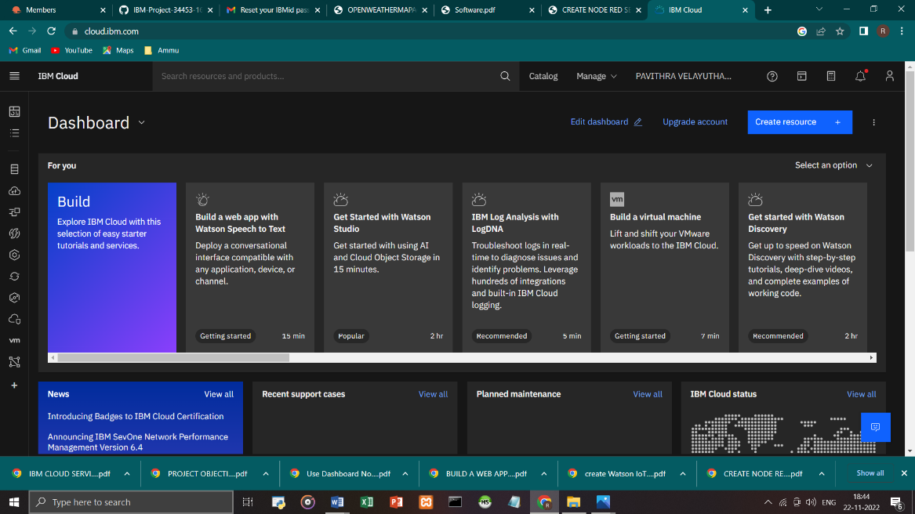

**TEAM MEMBER 3: HABINAYA.R**

